RH-ISAC Summit: Sponsor Marketing Kit

SOCIAL MEDIA PROMOTION
To help promote the RH-ISAC Cyber Intelligence Summit, please use the sample text below to highlight the event on your company’s LinkedIn and/or Twitter profiles.

{Company Name} is collaborating with @Retail & Hospitality ISAC as a sponsor for the upcoming Cyber Intelligence Summit on October 2 – 4 in Dallas, TX! Join us and the rest of the retail and hospitality cybersecurity community for a best-in-class event! Register today at https://summit.rhisac.org

Tag RH-ISAC in your post:
- Twitter: @RH_ISAC
- LinkedIn: @Retail & Hospitality ISAC

Add hashtags:

- #infosec
- #cybersecurity
- #RHISACSummit
- #ProtectAsOne
- Any others related to your company

Feel free to edit the suggested text above to fit your needs, but don’t forget to include the following:
- Session topic
- Date and time
- Register at https://summit.rhisac.org

Graphic:
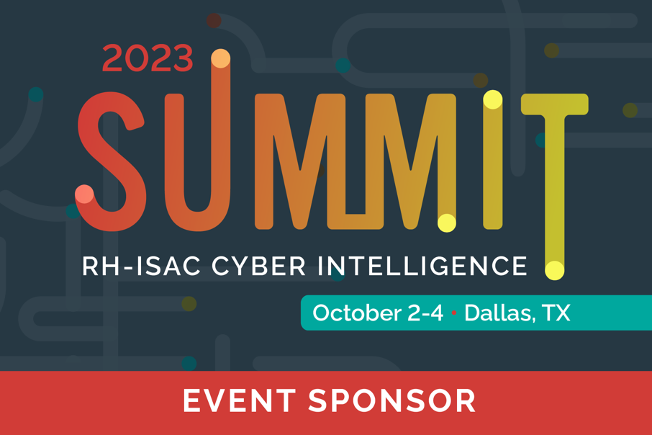

sample press release

To help promote the RH-ISAC Cyber Intelligence Summit, please feel free to use the below template as a starting point for a writing press release about the event.

[Company Name] Partners with the Retail and Hospitality at the Cyber Intelligence Summit

[City, State (Month XX, Year)] – [COMPANY NAME] today announced that it will partner with The Retail & Hospitality Information Sharing and Analysis Center (RH-ISAC) as a sponsor for RH-ISAC’s RH-ISAC’s Cyber Intelligence Summit.
The Summit is a two-day event that brings together information security professionals who work in retail, hospitality, or other consumer-facing businesses for networking and education with peers from around the world. This year’s event takes place October 2-4 in Dallas, Texas.
{Company Name’s} sponsorship will provide attendees with the opportunity to learn more about {Company Name’s} [product or service related to retail and hospitality cybersecurity needs].
The Summit is open to any cybersecurity practitioner that works in the consumer-facing sector. Registration is required. Visit https://summit.rhisac.org for more information.
###
About Company
[INSERT COMPANY BOILERPLATE]
About RH-ISAC
The Retail & Hospitality Information Sharing and Analysis Center (RH-ISAC) is the trusted community for sharing sector-specific cybersecurity information and intelligence. The RH-ISAC connects information security teams at the strategic, operational, and tactical levels to work together on issues and challenges, to share practices and insights, and to benchmark among each other – all with the goal of building better security for the retail, hospitality, and travel industries through collaboration. RH-ISAC serves all retail, hospitality, and travel companies, including retailers, restaurants, hotels, gaming casinos, food retailers, consumer products, and other consumer-facing companies. For more information, visit www.rhisac.org.

SAMPLE blog

To help promote the RH-ISAC Cyber Intelligence Summit, please feel free to use the below template as a starting point for a blog post on your company blog to promote the event.

Writing Your Blog:

- Your blog post should provide information about the event, why you’re sponsoring, with the call to action of learning more about your company by registering for the Summit.

Sample Blog Format:

Blog Title: Informative title, around 60 characters
Blog Description: 155–165-character description of the post

Paragraph 1: Introduce the RH-ISAC and the RH-ISAC Cyber Intelligence Summit. You can find information about the event on the Summit website.
Paragraph 2-3: Let readers know why you are sponsoring the event and how your company/product/service is relevant to attendees in the retail and hospitality industry.
Paragraph 4: Register for the RH-ISAC Cyber Intelligence Summit on October 2 – 4 in Dallas, TX to {call to action relevant to your organization’s customer base}

