RH-ISAC Summit
Attendee Social Media Toolkit

Follow us
RH-ISAC is active on LinkedIn, Twitter, and Facebook. Follow us to acquire live posts throughout the event!

- LinkedIn: @Retail & Hospitality ISAC
- Twitter: @RH_ISAC
- Facebook: @retail.hospitality.isac

Sample posts
RH-ISAC encourages you to post before, during, and after the event to get your network interested in what you’re learning at this year’s Summit! Here are some sample posts and a graphic to get you started.

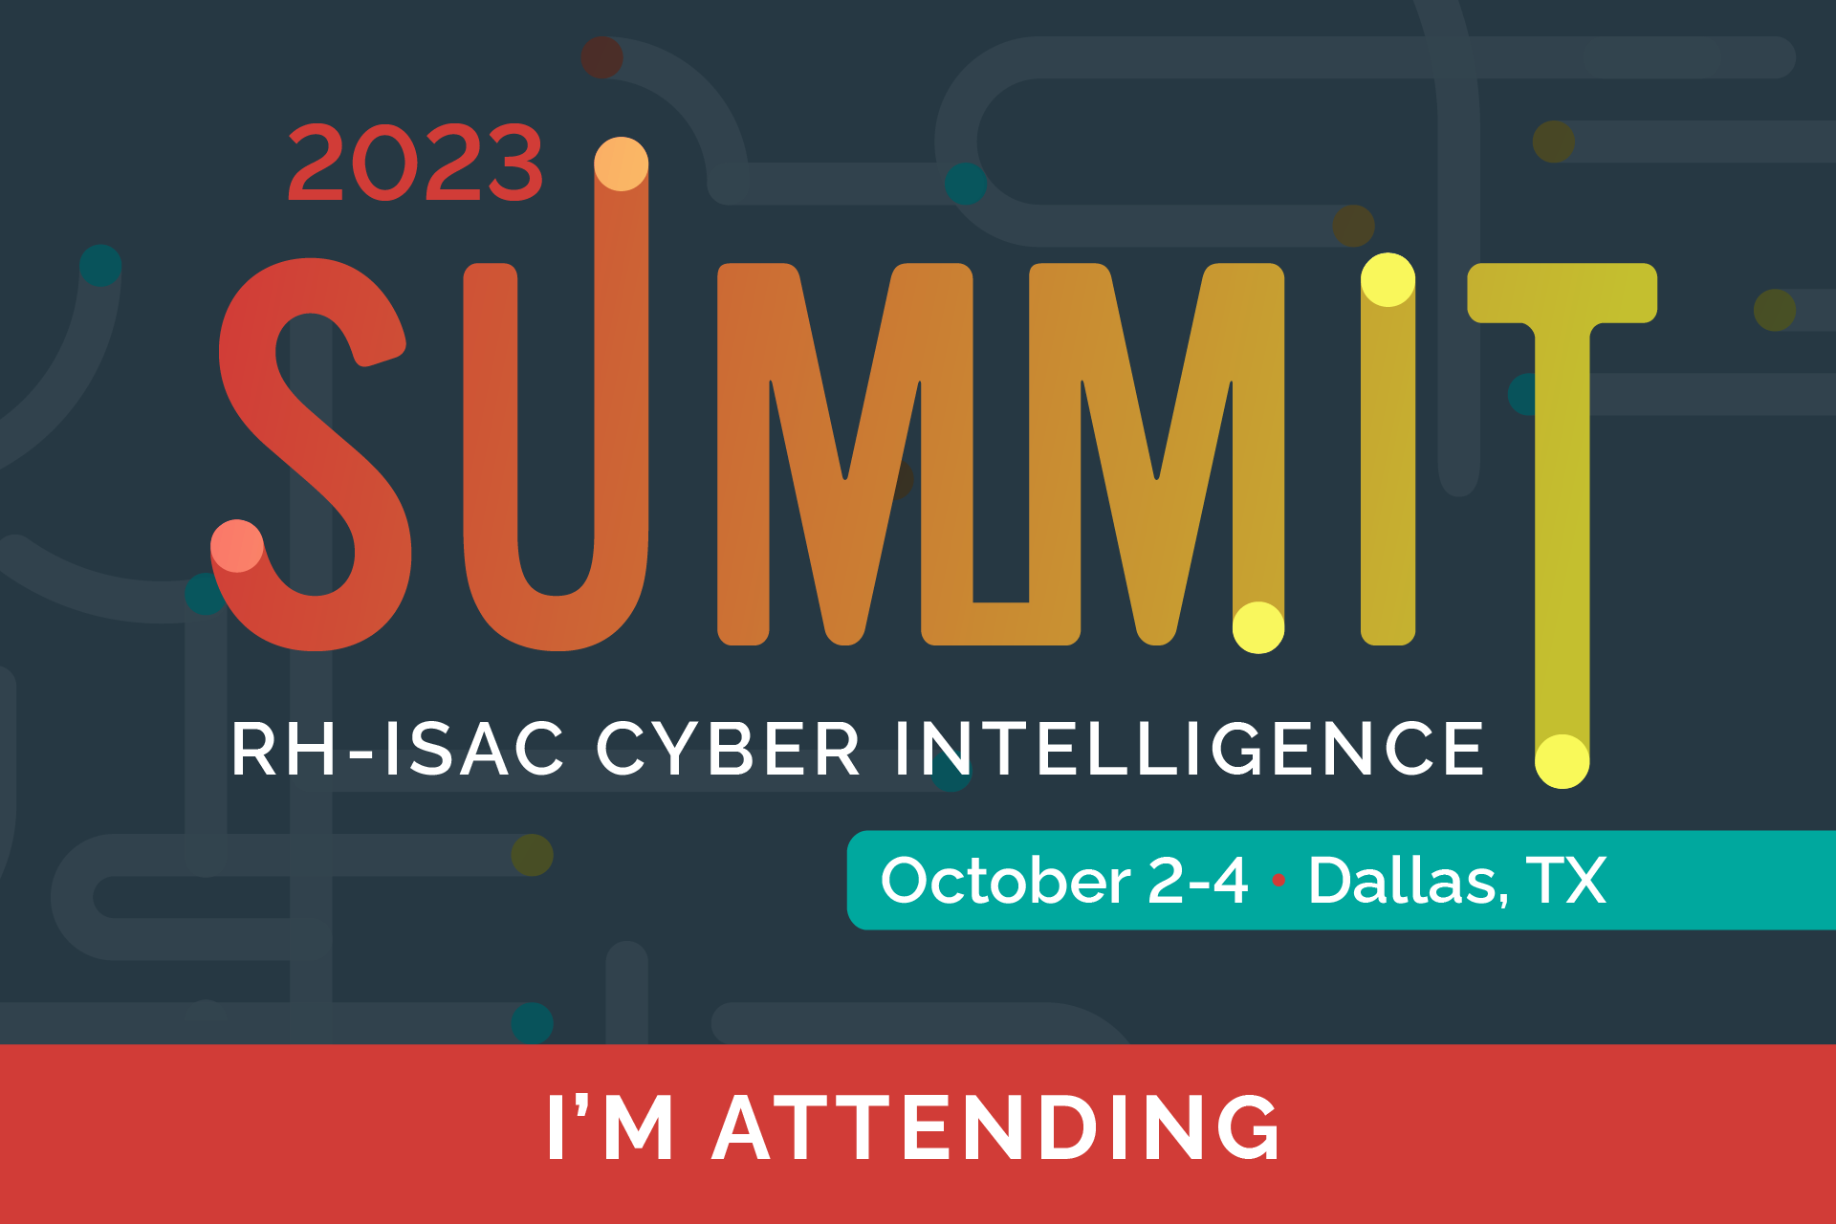

LINKEDIN
Option 1:
I’m registered for the @Retail & Hospitality ISAC Cyber Intelligence Summit, October 2 – 4 in #Dallas, TX! The event is open to all #cybersecurity practitioners working in consumer-facing companies. I hope to see you there! #ProtectAsOne #infosec #RHISACSummit https://summit.rhisac.org

Option 2:
I’m attending the @Retail & Hospitality ISAC Summit from October 2 – 4 in #Dallas, TX and would love for you to join me! I’m excited to connect with my retail and hospitality community for this event filled with breakout sessions, keynotes, and discussions dedicated to prevalent #cybersecurity topics. #ProtectAsOne #infosec #RHISACSummit https://summit.rhisac.org

TWITTER
Option 1:
Join me and @RH_ISAC at the premier event for #cybersecurity retail and hospitality professionals, taking place October 2 – 4 in #Dallas, TX! Sessions cover the latest and greatest topics in cybersecurity. #ProtectasOne #RHISACSummit https://summit.rhisac.org
Option 2:
I’m attending the @RH_ISAC Summit, October 2 – 4 in #Dallas, TX! This is the “can’t miss” event if you’re a retail or hospitality #cybersecurity professional! #ProtectasOne #RHISACSummit @RH_ISAC https://summit.rhisac.org
FACEBOOK

Option 1:
I’ll be attending the @retail.hospitality.isac Cyber Intelligence Summit in October! You won’t want to miss this conference if you’re a #cybersecurity professional in retail and hospitality! From the breakout sessions and discussions to curated keynotes, the most pressing cybersecurity topics will be covered! #ProtectAsOne #infosec #RHISACSummit https://summit.rhisac.org

Option 2:
I just registered for the @retail.hospitality.isac Cyber Intelligence Summit, October 2 – 4 in #Dallas, TX! I’m excited to connect with my colleagues in the retail and hospitality community for breakout sessions, keynotes, and discussions dedicated to pressing #cybersecurity topics. #ProtectAsOne #infosec #RHISACSummit https://summit.rhisac.org

